1. Go to SM59

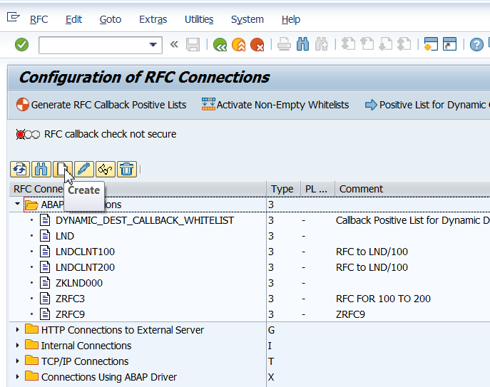

1. Enter details as shown below.

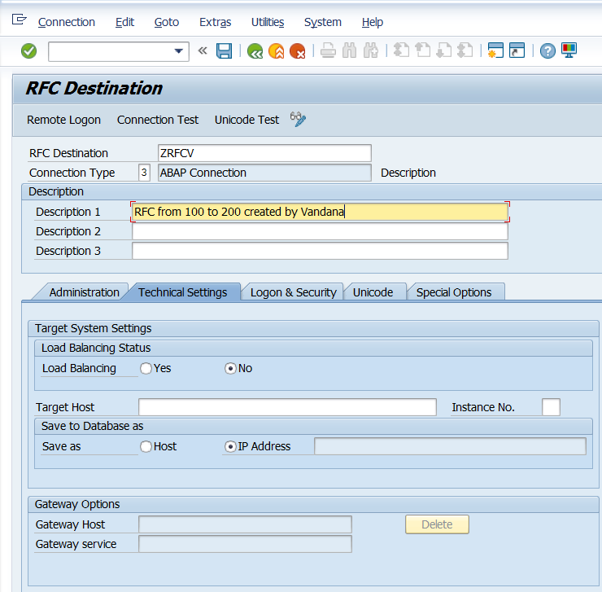

1. Click on Logon and Security. Enter details and credentials of client 200 as shown below.

Note: Currently, the user is logged in on client 100. Save.

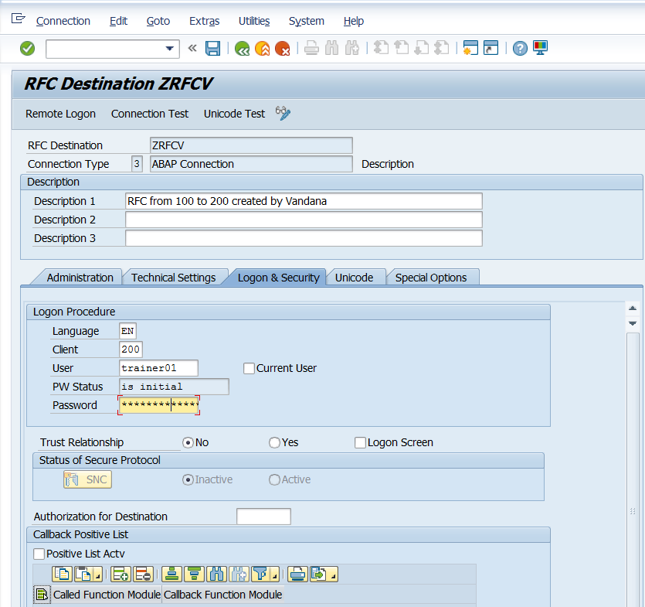

1. Click on remote logon.

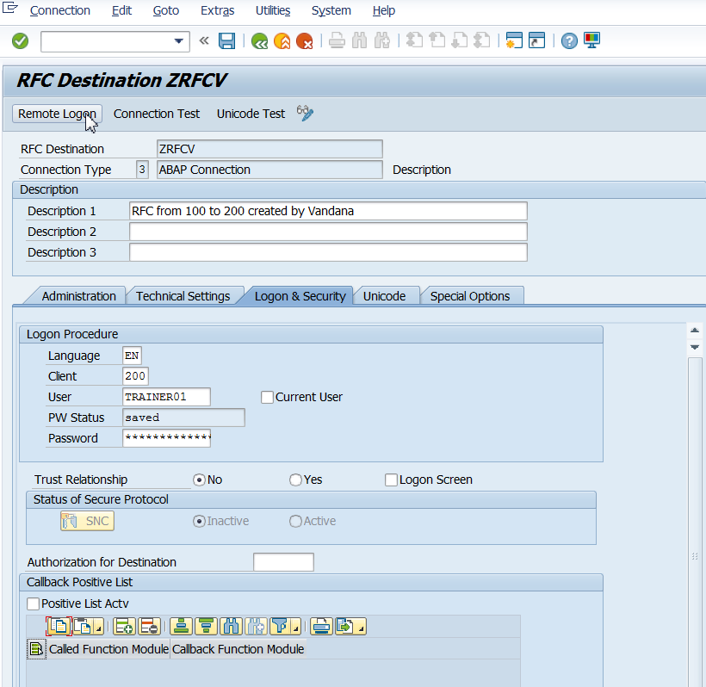

1. This will take us to client 200.

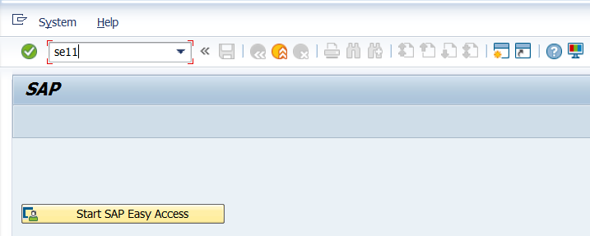

1. Observe the contents of MARA table.

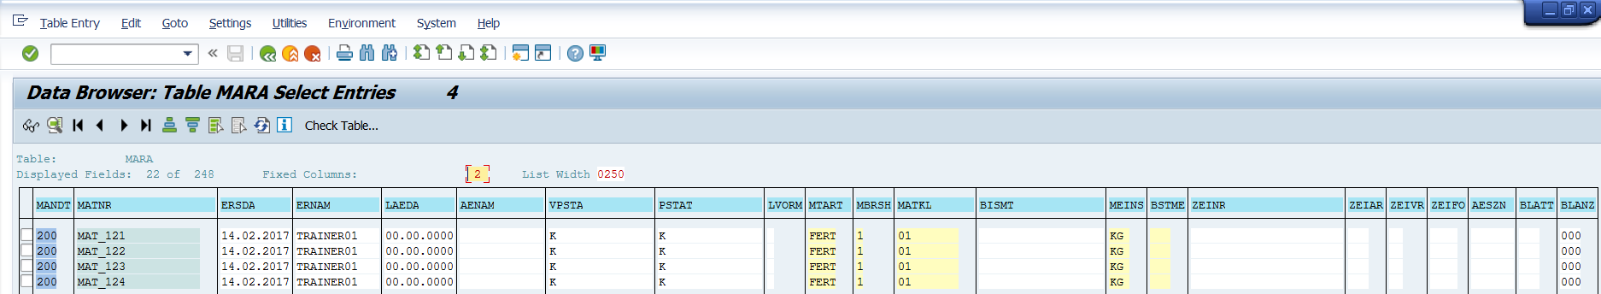

We want to see these details from the function call created earlier.

1. Press back till you come to the screen below. Logoff from client 200.

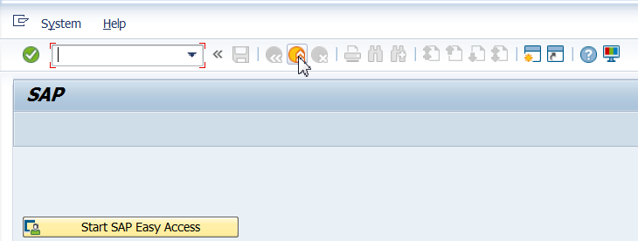

1. You will come back to client 100 screen. Save.

